ST10285098

Ahilya Surujpal

WEDE5020

POE - Part 1.pdf

**Table of contents**

|  |  |
| --- | --- |
| -Name of business.  -Description of business.  -Reason for business | page 3 & 4 |
| -Website assets | Page 5 & 6 |
| -Website pages and content. | Page 7 |
| -List of references. | Page 8 |

**NAME, DESCIPTION OF ORGANIZATION & REASON FOR THIS CHOICE.**

The name of the business that I will be doing my assignment on is called “GO CLEAN WITH GREEN”. This business aims to help rejuvenate our planet back into the healthy and positive state that it was in previously before pollution and deforestation came about. The business aims to bring community members together to help plant trees and involve themselves in beach and park clean ups to keep our environment clean and healthy, Go clean with green also raises donations to hold environmentally friendly get togethers that will help to bring the community together as well as to spread the word of planting more trees and keeping our environments clean for our future generation, our organisation aims to help build healthy and clean environments for our youth and upcoming generations.

Go clean with green is funded by NGO funding companies that are involved with funding small and upcoming businesses. The money is used to purchase planting equipment, seeds from all around the world (to grow a variety of different trees), host community get togethers, produce posters and to post the business on different kinds of media such as newspapers, magazines, YouTube ads and more! In this organization, we also intend on engaging with our youth by creating environment groups, clean up groups, planting groups, visiting schools and hosting fun activities just for the little ones, these types of involvement will help to teach our younger generations to always keep our environments clean and to always plant trees, fruits and vegetables to stay healthy and positive!

The reason I have chosen to do this type of organization for my assignment is because of my late grandfather who grew up in a farm where he always planted trees, vegetables and fruits. He believed that being in healthy, clean environments were there the key to happiness and success as he was taught that your mind is at its peak when the environment around you is clean and positive. I was very close to my grandfather and would plant a lot with him, planting was our way of bonding and I noticed that I was always at peace when I used to plant or just sit outside in the gardens and I believe that this is something that should be introduced more into the world as you can accomplish many things by being surrounded by nature such as spending family quality time, relieving stress and just getting rid of all the negative energy that holds you down.

Go Clean With Green is the way to go!

Website assets:

Pictures / texts to be used / LOGOS :

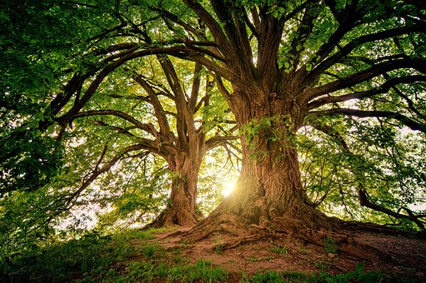



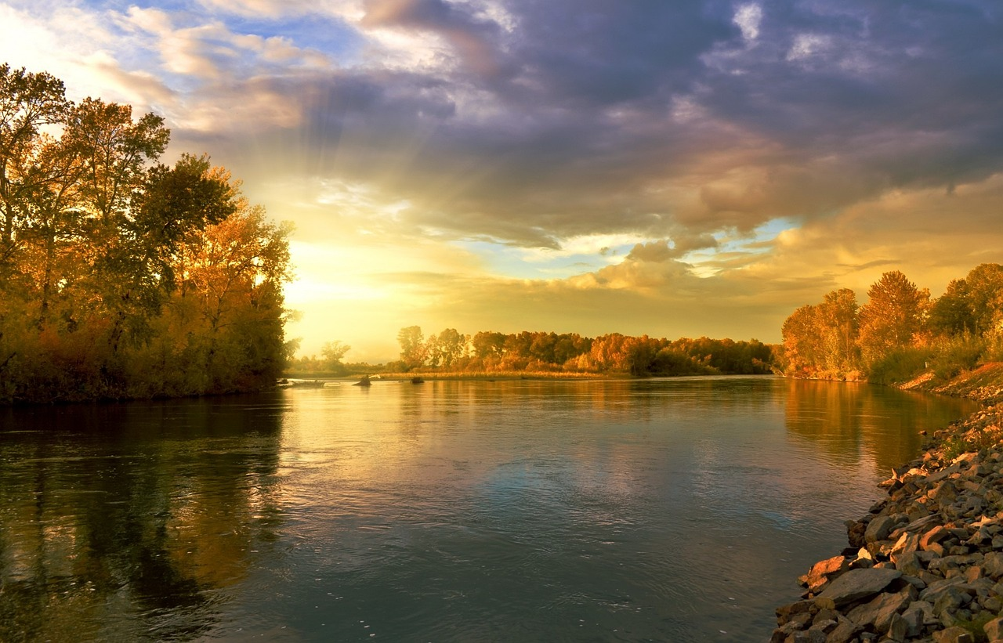

"Nature is not a place to visit, it is home." Gary Snyder.

Look deep into nature, and then you will understand everything better. —Albert Einstein

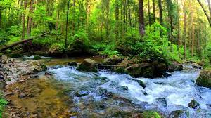

Website pages and content:

(Brief description of each page)

Page 1: WELCOMING AND DESCRIPTION OF THE WEBSITE AND ORGANIZATION.

* What our website is about.
* What we aim to achieve via our organization.

Page 2: WHAT OUR ORGANIZATION DOES AND HOW WE DO IT.

* What do we do (planting, cleaning, get togethers etc)
* How we do it? Forming groups, hosting events etc.

Page 3: FUNDING OF OUR ORGANIZATION AND DONATIONS TOWARD THE ORGANIZATIONS (what we use the money for)

* Ngo businesses fund our business, donations from the community.
* Advertising on media, hosting events, buying seeds etc.

Page 4: OUR GROUPS AND EVENTS

* Planting groups, clean up groups, event groups etc.

Page 5: HOW CAN YOU CONTACT US?

* Business e-mail, business number, Facebook, online registering etc.

List of references:

Tree image: <https://www.freepik.com/free-photos-vectors/tree>

Food and trees for Africa: <https://www.google.com/search?q=which+tree+is+the+best+for+helping+the+earth&oq=which+tree+is+the+best+for+helping+the+earth&aqs=chrome.69i57j0i395i546.54605j1j9&sourceid=chrome&ie=UTF-8>

Tree drawings: <https://www.google.com/search?q=tree+drawings&source=lnms&tbm=isch&sa=X&ved=2ahUKEwiPv_ni14P-AhXJbMAKHSTiDjAQ_AUoAXoECAEQAw#imgrc=IWT9jvq4LZ8KzM>

Trees:

<https://trees.org.za/?gclid=EAIaIQobChMIz7KY3t6D_gIVn4FQBh1SYgmJEAAYASAAEgKa5fD_BwE>

image:

<https://za.pinterest.com/pin/beautiful-waterfall-nature-videos-copyright-free-download-copyright-free-background-4k-free-stock--954692820979825319/>

quotes:

<https://parade.com/1034896/marynliles/nature-quotes/>

**PART 2**

Improvements to part 1:

Name of website: Go Clean with Green

At the start of my coding, my website had looked like this :

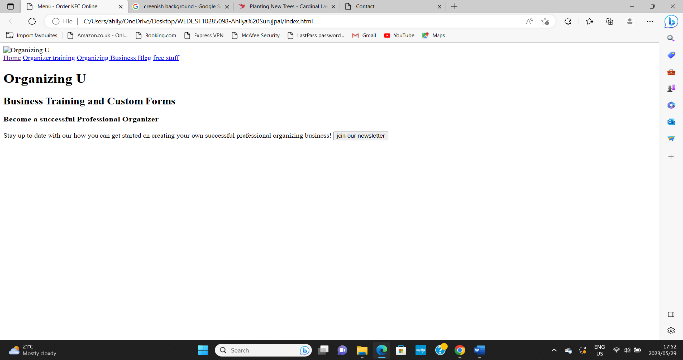

I had then started doing more research and learning on how I can improve my website and soon enough, I had managed to turn my website into this :

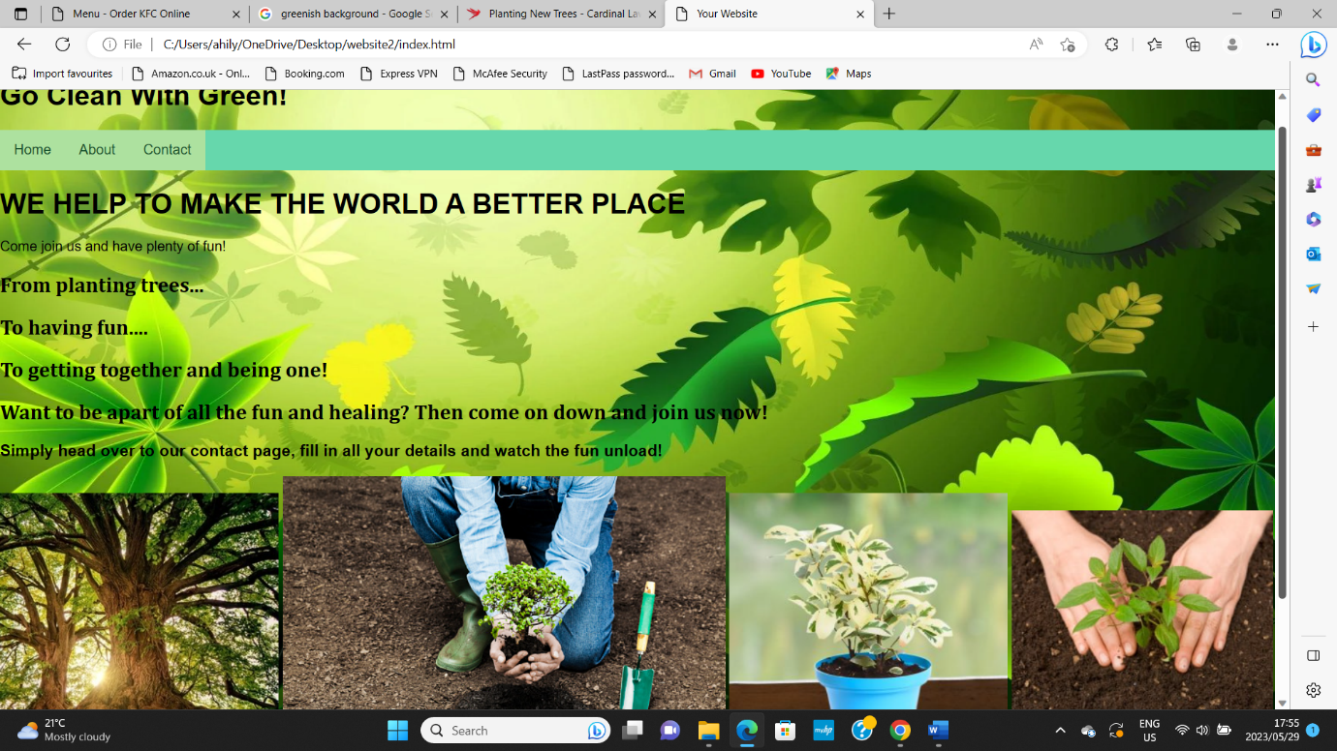

I improved on many different things in my website such as:

* Adding images.
* Adding backgrounds.
* Adding in colour.
* Adding a navigation bar.
* Making my website responsive.
* Adding information about my business in the about page.
* Adding a responsive contact page.

The images below consist of my current codes used in this website:

**The index page/The Home page**

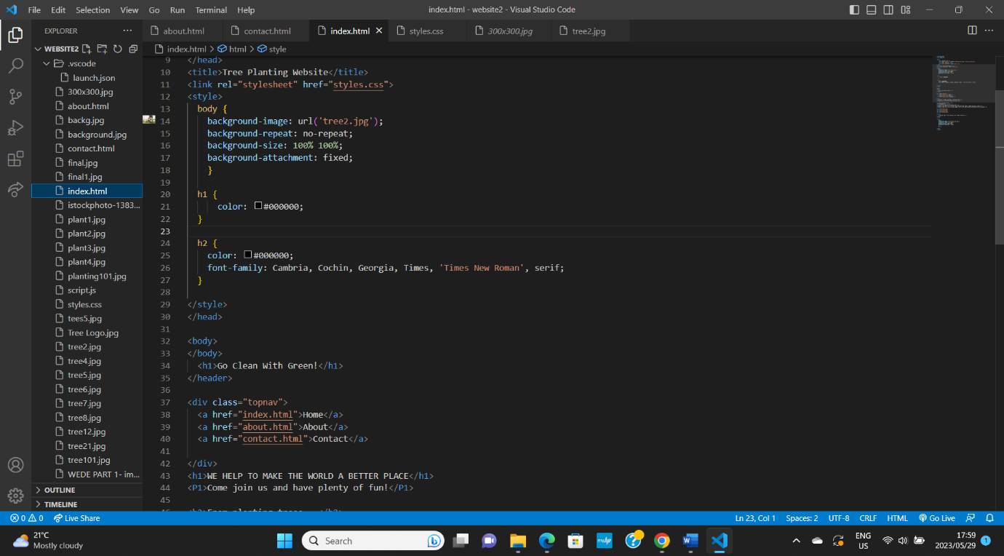

In my home page, I added in headings, a navigation bar, a background image, colours and images.

I used the following codes such as:

<styles> - for the editing of my colours and images.

<h1> - for my headings.

<title> - for the name of my website.

<div class – for the top navigation bar.

In my about page, I added in headings, colours, background images, paragraphs dealing with business and an ‘Our Team’.

<styles> - for the editing of my colours and images.

<h1> - for my headings.

<title> - for the name of the page.

<div class – for the top navigation bar.

<p1> - for the paragraphs and information on the business.

**The contact page**

In my contact page, I had done the exact same as I did in my other 2 pages, except that I added a ‘contact form’ that is responsive.

The website is responsive and is based on saving the planet by making the world a healthier and more positive place to live in for our future generations.

NTB:

I did try to open my folder with all of my assignment information in it, the folder did open up however when it came to navigating the different files, it did not allow you to pick the different files as it allows you too on vs code, it showed up as this:

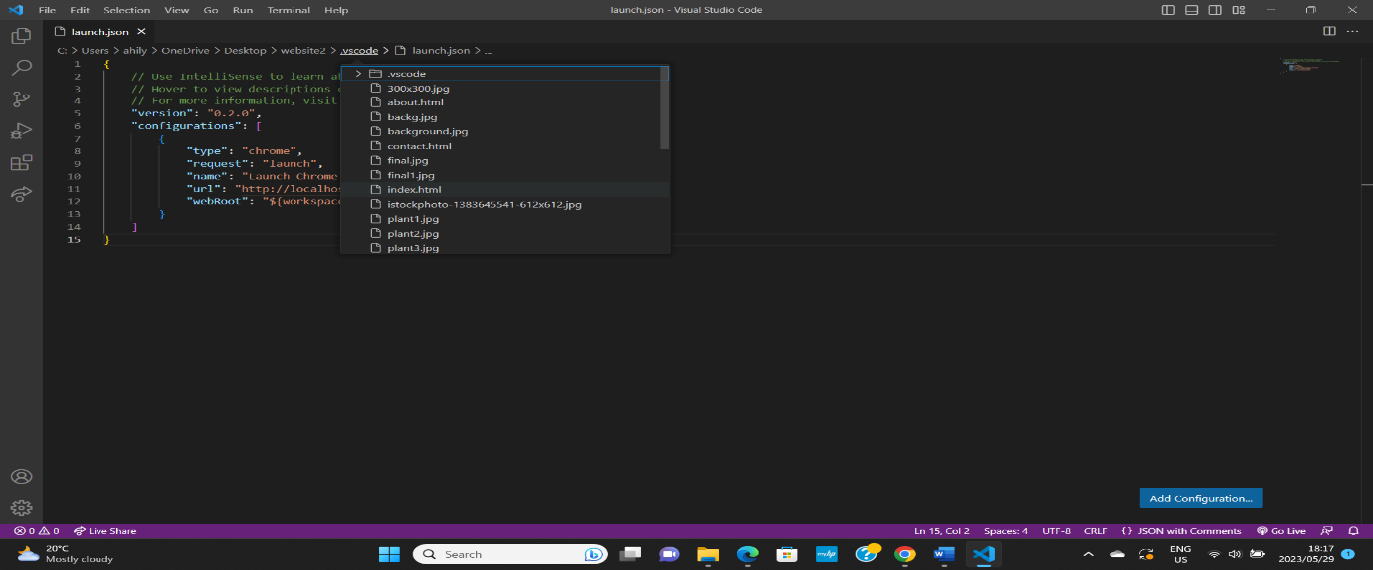

I was therefore only able to access my different files through this to make sure that everything was there and was working, thank you!